<!DOCTYPE html>

<head>

<style>

body {

font-family: helvetica, sans-serif;

margin: 0 auto;

max-width: 600px;

}

div {

height: 200px;

background-size:cover;

position: relative;

margin: 40px 0px 0px 0px;

border-radius: 12px;

}

.first {

background: url("http://dash.ga.co/assets/firstcourse.jpg");

}

.second {

background: url("http://dash.ga.co/assets/secondcourse.jpg");

}

.dessert {

background: url("http://dash.ga.co/assets/dessertcourse.jpg");

}

p {

color: rgba(255,255,255,1);

background: rgba(0,0,0,1);

padding: 10px;

text-align: justify;

line-height: 28px;

position: absolute;

bottom: 0;

margin: 0;

}

</style>

</head>

<body>

<h1>esha's restaurant</h1>

<div class="first">

<p>welsh onion soko $14<br />

<small>Mustard sierra leone bologi kale chard beet greens black-eyed pea sorrel amaranth garlic tigernut spring onion summer purslane asparagus lentil. </small>

</p>

</div>

<div class="second">

<p>pastrami boudin tongue $22<br />

<small>Tri-tip capicola kielbasa salami brisket chicken rump strip steak drumstick. Meatloaf chuck boudin ribeye pork jowl. Andouille bacon jowl meatloaf pork loin prosciutto bresaola.</small>

</p>

</div>

<div class="dessert">

<p>fruitcake marzipan pudding dragee $8<br />

<small>Lollipop tart cotton candy jelly-o carrot cake apple pie cupcake. Jelly-o bear claw ice cream candy canes.</small></p>

</div>

</body>

navigation bar: home about shop press contact view cart icon

stays as you scroll down

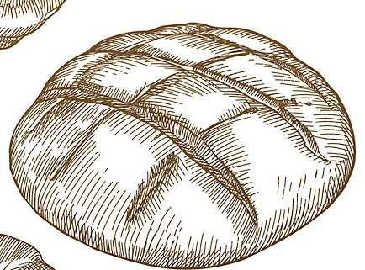

the loaf and a half bakery

Welcome to “the loaf and a half” bakery.

* we bake all of our bread ourselves
* naturally leavened, “no knead” traditional technique
* using high-quality, locally grown ingredients

BEST-SELLING LOAVES

33% spelt sourdough

100% German rye sourdough



Figure spelt



Figure rye



Figure baguette



Figure Einkorn



Figure whole wheat

Figure buckwheat

75% whole grain sourdough

classic Einkorn sourdough

10% spelt sourdough baguette

25% buckwheat sourdough

OPENING HOURS:

Mon – Fri: 7am - 5pm

Saturday: 8am - 6pm

Sunday: closed

SUBSCRIBE (form)

email address

social media icons

OUR STORE

address:

phone:

email: [info@....com](mailto:info@....com)